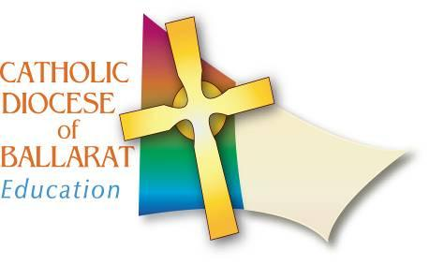
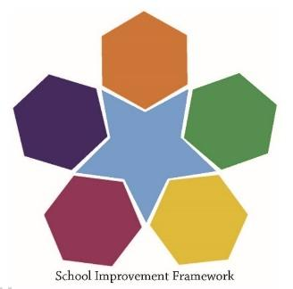

School Improvement Framework

St Patrick’s Primary School, Stawell

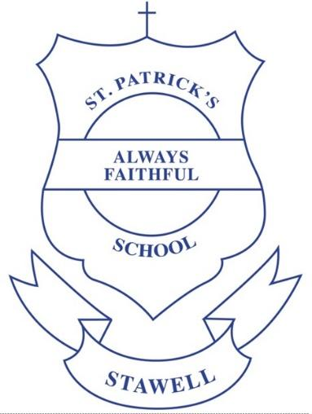

School Improvement Plan
2019 - 2023

Signed by Principal …………………………………………

Name …………………………………………

Date …... /..…. /…….

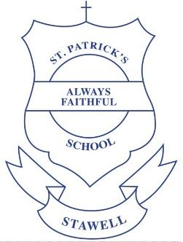

St Patrick’s Primary School, Stawell
School Vision and Mission

Vision Statement

St Patrick’s School is a community which reflects and celebrates Christ as its centre. By Honouring our story we value our whole community. By coming together our vision is for a loving, just, compassionate and tolerant world.
Prayer - We nurture and grow our relationship with God as members of a faith community
Care - We foster recognition of difference, compassion for others and the strength to act on our beliefs
Learning - We develop the knowledge, attitudes and skills essential in reaching our full potential as lifelong learners.

Mission Statement

In the tradition of St Patrick, we are committed to:
Protecting the safety and dignity of each individual
Promoting and celebrating a love of God, self, community and environment
Recognising and enhancing the talents and uniqueness of all through our vision, prayer, care and learning

School Contextual Statement

St Patrick’s Catholic Primary School is a Catholic co-educational primary school which was established over 100 years ago by the sisters of St Joseph. The school is located in Stawell. In 2017 a new principal was appointed and a deputy principal was also appointed in that year.
Numbers at the school have increased in recent years with the current enrolment of 154 students being the highest for this review cycle. The school has an ICSEA score 1033 of which is well above the national average of 1000 indicating that the school is in an area of considered low socio-economic advantage. CEVN reports suggest that 7% come from a family whose language background is other than English. The half of the students are from a Catholic background.
The school is situated on a relatively small site linked to the Parish Church. St Patrick’s operates in an old, but extensively refurbished building with a wide range of innovative inclusions. Facilities include a hall, a library, an Art room 7 classrooms, a teacher resource room, reception and administrative area. The grounds have been effectively developed with areas for active and imaginative play. The grounds and equipment are colourful and appealing to students. There are some shade areas around the school.
The students are organised in 7 classes – one Prep, two 1/2, two 3/4 and two 5/6 groupings. Specialist programs are in Performing Arts, Digital Technology, Physical Education and LOTE (Chinese). The school is further supported by a Reading Recovery teacher. Co-curricular offerings allow students opportunities to develop interests beyond the classroom and they include sporting programs, school choir and chess club.
The school caters for 13 students with disabilities who receive Students with Disabilities (SWD) funding and has a strong focus on the holistic development of the child within its Catholic ethos.
According to CEVN data there are 25 teaching and 3 non-teaching members of staff. Each member of the leadership team has a specific role to play in ensuring leadership in all spheres is well managed. There are a number of long standing staff members with the most recent Annual Report to the Community (2017) indicated that the staff retention rate was 85.71%.
Situated in the same street is as St Patrick’s Church, the school is connected to the parish, working with parish members on a range of faith and social activities.
St Patrick’s new and refurbished buildings were completed in 2016 and the beginning of 2017 enabling the school to start the 2017 school year with a newly built multi-purpose learning hub that offers the school community an opportunity to teach and learn within dynamic, innovative learning environments.
The learning environment has been dramatically altered through the inclusion of flexible furniture, providing dynamic, differentiated learning experiences tailored to the individual student. It acknowledges the 21st-century demand for enterprise skills such as problem-solving, collaboration, critical thinking, digital literacy, and presentation and communication skills and an ongoing commitment to student-centred, personalised learning, and support for the wellbeing of all members of the school community.

Overview
The review and validation process for St Patrick’s Primary School is directed by Catholic Education, Ballarat School Improvement Framework (revised 2015). The School Improvement Framework provides a process for improving student outcomes in learning and wellbeing in the Diocese of Ballarat. It takes into account school culture, leadership, learning and growth of all within the school community.
The School Improvement Framework provides a cyclical structure for the school to focus on what is important for the school to improve. It nominates the key drivers of leadership, collaboration, evaluation, reflection and evidence-based decision making. It draws on the National School Improvement Tool (2012) and other frameworks to enable the school to build a culture of shared responsibility for improving the outcomes for all students. It accounts for the five national reform directions (quality teaching, quality learning, empowered school leadership, meeting student need, transparency and accountability) and promotes evidence-based strategies and innovation, encouraging schools to continually ask important questions about student learning and future directions. It includes annual actions around:
- reflecting on and analysing school performance
- implementing elements of the long-term school improvement plan
- developing and implementing the annual action plan
- meeting compliance and reporting obligations
See also: BDSAC School Improvement Policy (2015)
School Improvement and Accountability Schedule (2016-2019)

The school is informed and guided by The Characteristics of a Highly Effective Catholic School (CEB 2016) which clearly articulates a standard for schools in the Ballarat Diocese around effective practice. It highlights the importance of a central vision and the aspects of school operation that flow from this vision.
Catholic School Culture | - Religious Education  - Enhancing Catholic School Identity  - Social Action & Justice
Community Engagement | - Partnering with Families  - Community Partnerships
Leadership & Stewardship | - Shared Leadership  - Building Staff Capability  - Ensuring Effective Governance  - Stewardship Of Resources
Learning & Teaching | - A Guaranteed and Viable Curriculum  - Effective Teaching  - Engaging Students In Their Own Learning  - Analysis and Use of Data  - Coordinated Strategies for Intervention
Wellbeing | - Quality Relationships  - Wellbeing Practice  - Safe Learning Environment  - Rights and Responsibilities

The Characteristics of a Highly Effective Catholic School highlights the necessity for the school to implement a guaranteed and viable curriculum. At this time, the school is implementing the Victorian Curriculum (2017) which includes cross-curriculum priorities related to learning about Aboriginal and Torres Strait Islander histories and cultures. The school also accepts its obligation to provide a safe environment for staff and students, as mandated by the Victorian Child Safe Standards.

Long term School Improvement and annual Action Plans are developed collaboratively by the school’s governing authority, school staff, School Advisory Council and the Catholic Education Office, Ballarat. The school reports annually to the school community on it achievements and ongoing plans for improvement via the Annual Report to the School Community, as required by the State and Federal authorities. This report is published on the VRQA State Register and is available on request from the school. This school improvement plan will also be published in a form readily accessible to the public

Key Improvement Priority One

Key Priority  (A key improvement that will maximise student learning) | Links with the CHECS Components  that will drive this priority
Developing components of PLC to build teacher capability, foster student engagement for learning and improve student learning outcomes. | Vision and Mission  Catholic School Culture  1.1 Religious Education  Leadership and Stewardship  3.2 Building Staff Capability  3.3 A Culture of Continuous Improvement  Learning and Teaching  4.1 A Guaranteed and Viable Curriculum  4.2 Effective Teaching  4.3 Engaging Students in Their Own Learning  4.4 Analysis and Use of Data  4.5 Coordinated Strategies for Intervention

Possible Strategies and Actions that will address this Priority
Identify and gain a shared understanding of the Essential Learnings for St Patrick's.
Develop and implement an agreed pedagogical framework.
Develop consistency in practice across the school.
Build the capability of teachers to assess student learning and to use data more effectively.
Further develop and embed the PLC and learning cycles, exemplifying what best practice looks like.
Build teacher capability to empower students in their learning.
Develop a culture of effective feedback across the school.
Define and develop RTI process and ensure its implementation.
Unpack curriculum and develop proficiency scales through a PLC lens.
Implementation Overview
Over the next four years staff and leadership will continue to unpack the Essential Learnings for all key curriculum areas with a view to further developing proficiency scales.
By the end of Term 1, 2019 the Leadership Team and the RtI Leader will define and develop RtI processes and Intervention timetables. These will then be implemented by the PLC Teams.
Over the next four years Staff and Leadership will develop and implement an agreed pedagogical framework which will ensure consistency and best practice across the school.
Over the next four years, at weekly data meetings, PLC Teams will assess, analyse and share data and provide timely feedback to the learning community.
Over the next four years in order to empower student learning, teacher capability will continue to be built and developed through ongoing Professional Development.

Key Improvement Priority Two

Key Priority  (A key improvement that will maximise student learning) | Links with the CHECS Components  that will drive this priority
Enhancing the wellbeing of staff and all students. | Vision and Mission  Catholic School Culture  1.3 Social Action and Justice  Community Engagement  2.1 Partnering with Families  Leadership and Stewardship  3.1 Shared Leadership  Learning and Teaching  4.2 Effective Teaching  4.3 Engaging Students in their Learning  Wellbeing  5.1 Quality Relationships  5.2 Wellbeing Practice  5.3 Safe Learning Environment

Possible Strategies and Actions that will address this Priority
Develop a systemic plan.
Provide ongoing Professional Learning to build a contemporary, evidence based community approach to Wellbeing.
Embed best practice in wellbeing from an evidence based approach.
Audit current practices and explore the possibility of using the PAT Student wellbeing survey.
Strengthen communication of wellbeing strategies including establishing a space for parent/teacher and providing resources for parents and teachers, including our website.
Employ a Wellbeing coordinator.
Implementation Overview
Brief statement:
When, How and By Whom?
- Optional survey from Alan Hutchison completed by staff - Term 4, 2018
- Compulsory staff survey to assess needs of staff - Term 1, PRIORITY
- Revise current wellbeing program Bounce Back/Zones - Term 1, 2019 - PRIORITY
- Complete PAT Student Wellbeing survey to assess needs of students - Term 1, PRIORITY
- Structured and formal Wellbeing programs (what expertise do we have on staff) -
- Contact with Alan Hutchison - possibly Term 1 to put a plan in place
- Do we have a Wellbeing policy?? Development of policy
- Building resilience in all students
- New staff PLC structure - supporting teachers in classroom, extra time release - Staff allocated Term 4, 2018 to begin Term 1, 2019
- Restructure of specialist subjects - reduced to Sport, Performing Arts, Chinese and Visual Arts Term 4, 2018.
- Cybersafety - Esmart Team
- Update and provide all staff with a Staff Handbook - Day 1, Term 1, 2019
- If any staff are graduates ensure they have a mentor allocated with a set role description
- A wellbeing team with a coordinator will be allocated with a clear and formalised role description
- Possible grant for funding to employ a qualified counsellor

Key Improvement Priority Three

Key Priority  (A key improvement that will maximise student learning) | Links with the CHECS Components  that will drive this priority
Determining and implementing an appropriate and agreed leadership model informed by PLC culture. | Vision and Mission  Catholic School Culture  1.1 Religious Education  1.3 Social Action and Justice  Leadership and Stewardship  3.1 Shared Leadership  3.2 Building Staff Capability  Learning and Teaching  4.4 Analysis and Use of Data  Wellbeing  5.1 Quality Relationships

Possible Strategies and Actions that will address this Priority
Provide opportunities for staff to connect with other schools for professional development
Strengthen the focus and communication around student engagement and feedback
Provide opportunities for staff to bring back professional development to all staff
Establish collective opportunities with other schools to explore contemporary, innovative and best practice
Provide professional learning opportunities for all staff eg techie breakfasts, Catholic Education Office staff visits

Implementation Overview
Brief statement:
When, How and By Whom?

Throughout the next four years we will provide opportunities for all staff to connect with other schools for professional development.

St Patrick’s staff to visit other schools currently undertaking PLC to look at their PLC process’ structures, contemporary and best practice teaching. Staff to connect with other schools and staff at professional development days and to run Professional Development sessions to present their learning back at school.

Throughout the next four years we will utilise team teaching to allow opportunities for students and teachers to engage in individual student conferences to discuss individual student achievements and goals. We will develop effective and efficient timetabling to allow this to happen.

St Patrick’s primary school will provide learning opportunities about how feedback looks from a PLC perspective and provide opportunities to develop a consistent approach to student feedback. The Guiding Coalition Team will source information and practices and bring them back to St Patrick’s Primary School.

Throughout the next four years all staff (individual or as whole staff) will be given opportunities to engage in Professional Development with Catholic Education Office or external agencies.

St Patrick’s primary school will create a Professional Learning Plan for all staff where staff can write their goals and proposed Professional Development in their Professional Learning Plan. Individual staff members will meet with Principal once per semester to review their learning goals and achievements. Principal to advise staff members on Professional Development that may suit their learning goals.

